**WORK INSTRUCTIONS FOR_ SHUTDOWN OF BLAST FURNACE - II**

Responsibility: Shift Superintendent

PROCEDURE FOR SHUTDOWN OF FURNACE NO. II

Identified Hazards:

1. Fall, slip of a person
2. Mechanical impact
3. Contact with graphite dust
4. Fire & Explosion in the gas line
5. Electric shock
6. BF gas leakages
7. Contact with flame
8. Contact with hot metal/slag
9. Contact with hot water
10. PPE’s noncompliance.
11. Improper house keeping
12. Inadequate local lighting
13. Not using CO detector
14. Working in a hurry and getting hurt
15. Burns due to electric shock
16. Dust inhalation
17. Contact with Pulverised coal
18. Contact with hot surface
19. Contact with hot coke
20. Contact with compressed air
21. SOP violation
22. Not concentrating while at work
23. Ignorance casual approach

Significant Aspect:

1. Emission of BFG

2. Usage of water

3. Generation of dust

4. Usage of pulverized coal powder

Non standard tool approved by safety dept.

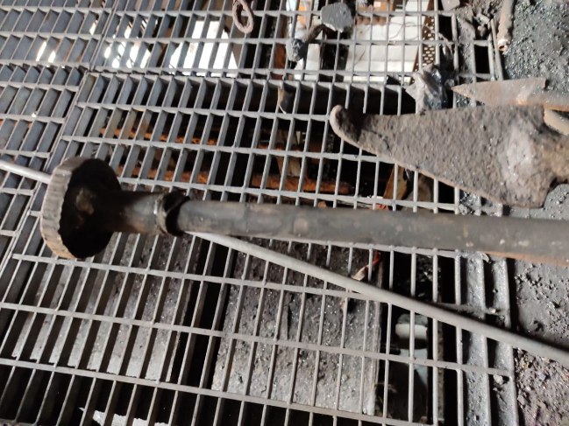

Dolly used for plugging the tuyere

PROCEDURE FOR SHUTDOWN OF FURNACE NO. I1

OVERALL RESPONSIBILITY: Shift Superintendent

Procedure:

1. Unauthorized operation or repair of any equipment is a punishable offence.
2. Whenever shutdown is to be taken, ensure furnace is hot/normal condition, unless and until it is required for emergency for which instruction is to be taken from GM/AGM production.
3. Before opening the cast inform service department, HOD’S & GEL regarding the furnace shutdown.
4. Stop batching of raw material in advance as per planned shutdown timings and empty all weighing bins incase weighing bins calibration is to be done.
5. Top gas temperature to be control around 250⁰C by judiciously dumping and by using top water spray.
6. Ensure steam in between the bells. Stop Pulverized coal injection (If running) 1 hour before the shutdown. Take all lances on Nitrogen.
7. Open the cast. As the cast starts blowing reduce wind volume gradually to 15000 Nm3/hr. (0.50 Kg/cm2 pressure). Blow the furnace for 5 min. so that all the metal and slag is drained out and close the cast. After cast closes, ensure that all PCI lances have been taken out and flushed. Ensure person caring out the activity wear proper PPE’s viz safety over coat, safety helmet with screen, safety shoes and hand gloves. Open and blow the dust catcher to remove all dust. (Preferably when IVC is full closed).
8. Ensure last dump to be coke incase top firing is to be done with top gas temperature around 300⁰C.
9. Inform GEL regarding the gas availability and shutdown.
10. Connect the furnace to the flare stack by water sealing the main gas line near bf2 dust catcher. Control the gas line pressure by opening flare stack valve.
11. Ensure two CO monitor is used while water sealing gas lines.
12. Ensure gas flow to GEL is continuous/uninterrupted from the other running furnace.
13. Ensure that furnace is not hanging while taking shutdown. If hanging give a forced check and ensure the furnace has slipped before taking shutdown.
14. Inform GEL to charge the steam header so as to get 5 kg/cm2 pressure.
15. Reduce wind volume to 6000 Nm3/hr (0.30 Kg/cm2 pressure) by opening snort valve and

keep 2 blowers on run. Open steam in uptakes, dust catcher and saturator.

1. Put venturi-2 in manual mode and open both the venturies fully.
2. Open relief valve and close the equalizing valve.
3. Ensure that EV- 1 is disabled by removing the fuses. Keep the permit in custody of control room Engineer.
4. Start water sealing the saturator as the blast pressure starts increasing open one bleeder. This should be the electrical winch bleeder which is operated from panel in cast house area by furnace incharge. Healthiness of electrical bleeder winch to be ensured prior to shut down. Has to be kept engaged.
5. Water seal the Common water seal of all three-stove gas lines. and main line water seal at bf2 dust catcher and also the main gas line of bf2 at bf1 main water seal, all water sealing valve wheel to be lockout with lock out pad after water sealing and ensure slight continuous over flow of water from the seal and lock out pad to be used. Both water sealed is must during shutdown.

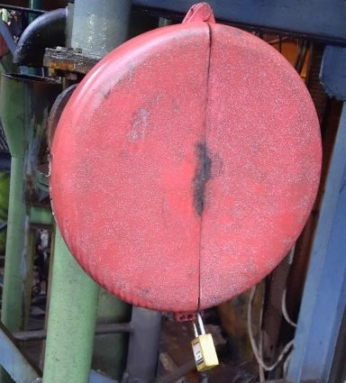

1. Box-up the other two stoves which are not on blast and stop ID and CA fan.
2. After the saturator gets water sealed open second bleeder.
3. Reduce the furnace pressure gradually to 0.05 Kg/cm2.
4. Open two peephole flange, ensure no person is standing in front of the blowpipes, to avoid burn injuries due to flying hot debris or hot coke from inside the furnace.
5. Don’t allow any person to pass in front of the blowpipes whose peephole flanges are kept open till back draught of the furnace.
6. Ensure that the curtain of cerewool cloth in front of tuyere is lowered before taking shutdown.
7. Back draught the furnace after opening two peep hole flanges and ensure no persons are standing in front of the blow pipes to avoid gas poisoning& burn injuries in case of back fire.
8. Select back draught mode.
9. Put stove in SEMI AUTO MODE.
10. Isolate ON BLAST stove to ISOLATION STAGE.
11. Close MMSV valve.
12. Close furnace isolation valve
13. Go to any stove & open coffe pot latch
14. Open cap. Whenever there is instruction for back flushing, back flushing to be done as per procedure mentioned in respective WI. (In case Back - flushing of stoves is planned, ensure all 4 blowers are running. After top firing, back flushing of stoves to be done as planned. Then blowers can be stopped).
15. Stop 3 blowers and keep one blower running till top firing.
16. Open all peephole flanges.
17. Check all tuyeres and tuyere coolers for water leakage by inserting a cold/dry rod inside the blowpipe and checking for dampness or by blowing slight compress air.
18. Persons carrying out the tuyere checking/plugging activity should wear safety coat, screen helmet, hand gloves, safety shoes. As furnace may slip creating backfire or hot coke thrown out from the blowpipe.
19. Care to be taken that the damp or hot rod is not used for checking tuyere water leakages.
20. Plug all tuyeres with hydrous clay and give clearance for top firing. Ensure no body is within the vicinity of the plugged tuyeres till the time top firing is complete. For top firing ensure permit is taken and two co monitor is used, minimum two person has to go for top firing. (One should be the senior most staff of the shift) Top hatch to be opened with the help of lancing hook by standing one mtr away from manhole to avoid burn injury due to sudden ignition of gas and auto slip of furnace. After top firing is observed wire mesh which is provided is to be placed on opened flange and secured with wedge pin.
21. After top firing stop last blower, open dust catcher bell and sliding gate, stop steam in between bell, uptake dust catcher. Stop CA fan, ID.
22. Steam purge gas line by opening relief valve one by one.
23. Ensure only two tuyers peephole flanges are kept open where people movement is less preferably tuyer no.1 and 8 and others to be loosely closed.
24. After saturator is water sealed, stop the GCS and venturi pumps.
25. Keep the flare stack actuator valve closed after water sealing the flare stack.
26. Open and replug all the tuyeres one by one after 01-02 hour of shutdown for rechecking of water leakage also ensure that no body is working on bleeders, bells and other confined areas at furnace top such as charging hopper.
27. Stop furnace stack shell cooling water half an hour and bosh cooling one hour after reducing wind volume to zero and keep all water sprays on for tuyere, tuyere coolers, cooling plates & below the tuyere/taphole level.
28. Do not stop or reduce the water of tuyeres, tuyere coolers and copper cooling plates in the bosh region in shutdown for short duration. However, if the S/D is of more than 3hours reduce water in copper cooling plates such that delta T (temp. difference between outlet & inlet) is maintained same as in running furnace (3 deg) and keep monitoring outlet water temperature and outlet flow of cooling plates. All individual cooling plate inlet water valves are to be made free.

|  |  |  |
| --- | --- | --- |
| **Prepared By:**  Head – Production PID I | **Reviewed & Issued By:**  Management Representative | **Approved By:**  Head – Pig Iron Division |
| **Signature:** | **Signature:** | **Signature:** |
| **Date: 10.07.2023** | **Date: 10.07.2023** | **Date: 10.07.2023** |

|  |  |  |  |
| --- | --- | --- | --- |
| **Amendment Record** | | | |
| **Revision date** | **Manual Section ref. and para** | **Brief details of revision** | **New Revision No.** |
| 12.07.2021 | Procedure for SHUTDOWN OF BLAST FURNACE - II | Point no 7,20,35 | 14 |
| 15.07.2022 | Procedure for SHUTDOWN OF BLAST FURNACE - II | POINT 20 | 15 |